Booking Feature

# Appendix

1. Booking Feature UI and the variables
2. Booking Feature Overview
3. TODO Tasks
4. Topic: Requests to Exchange Server
5. Topic: How to use Postman to Test Requests
6. Topic: Different Types of Authentication

# 1. Booking Feature UI and the Variables:

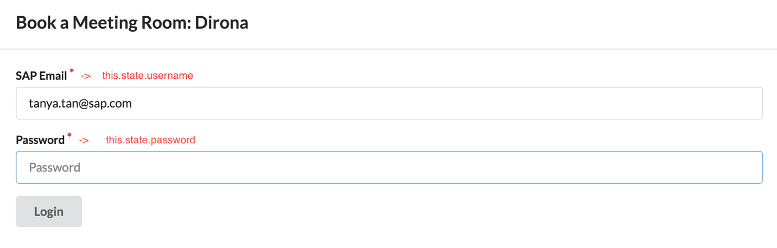

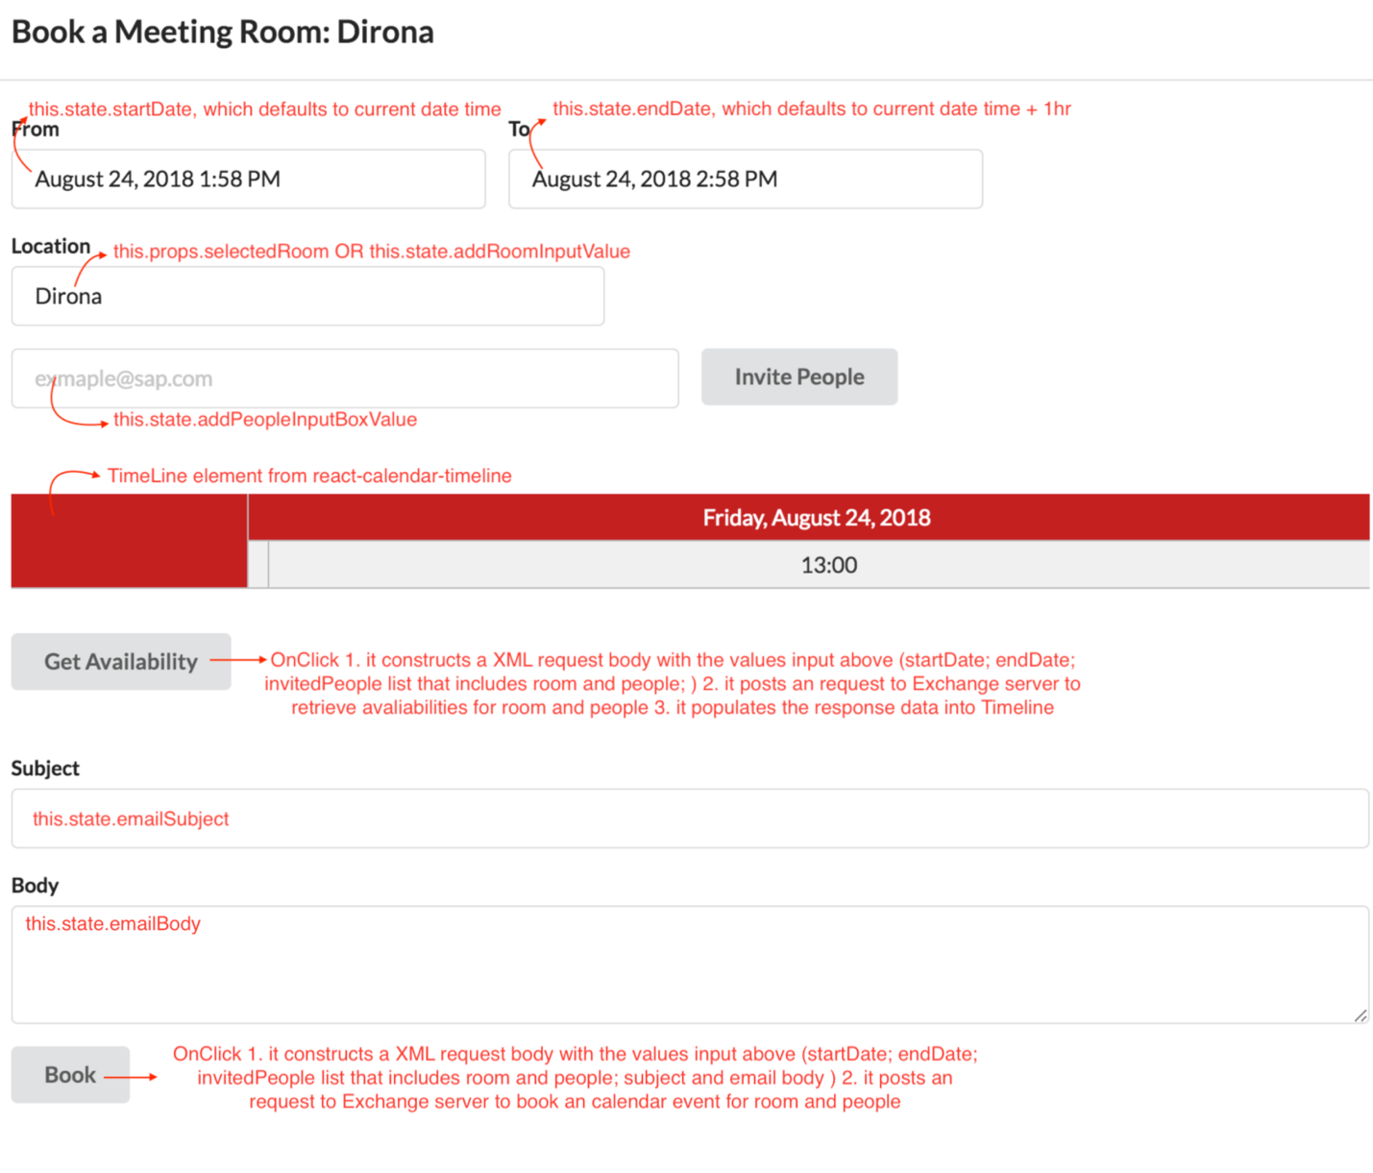

# 2. Booking Feature Overview

1. Log in Form

* Click **Login** button, updates **this.state.username** and **this.state.password**
* Calles **getBasicAuth**() to encode username and password into a basic auth code, and update **this.state.basicAuth** with returned value

1. Select Start date and End date

* Update **this.state.startDate** and **this.state.endDate** with selected values
* Update **this.state.availabilityStartTime** with this.state.startDate and **this.state.availabilityEndTime** with this.state.endDate plus 2 more weeks. So that when the selected time doesn’t work, the user is able to decide for future time.

1. User to enter a **Room**( if an user open booking dialog directly from Tool Bar); Otherwise, the room/Location will be default to the one user are looking at(if an user open booking dialog from Room Details) and the email of the room will be populated into the list of invited people.
2. User to enter the emails of people the user wants to invite to the meeting. Once the user finishes entering an email, click **Invite People** button, it populates the email into the list of invited people. User can enter as any emails as the user wants.
3. Click **Get Availability** button, it sends a request to the exchange server with the data input from above( availability start time, availability end time, the emails of list of invited people) and render the data returned by the server into the Timeline.

PS: at the moment, if the start time and end time the user selected are busy and the user wants to book the meeting for a different time. Then the user needs to update the selected values in Step 1).

1. User to enter email subject and email body
2. Click **Book** button, it sends a request to the exchange server with the data input from above(selected start time, selected end time, email subject, email body, location, emails of list of invited people) to book an calendar event.

If you have any question towards the requests you are sending to the exchange server, please refer to the document links in the next section: Request to Exchange Server.

# 3. TODO Tasks (Proposal):

## Security Concept

Go through Security Concept progress. Here are the people you can reach out for help. **Security Concept is a very necessary and the first thing we should do for booking feature.**

Without Security Concept we can not deliver this feature at all. When we do security concept, we need to be very detailed about the general information about the app, the way the app is going to interact with another server(here is SAP Exchange Server), what data we will retrieve from the server and how we are going to use this data. There are more details.

I highly recommended you to reach out to **Jennifer** **Lemmen** ([jennifer.lemmen@sap.com](mailto:jennifer.lemmen@sap.com)). We have talked with her about our app and she would definitely like to help. But due to time constraints, we could not really start the progress.

**The progress will take up to few months, so please start this progress at the very beginning!**

## Booking Feature Source Code

The code in the PR is not working with the new repo, but it is working with the old repo( <https://github.com/sfaigan/ixphackathon/pull/4> ). I just copy and paste the code into new repo, but somehow it is not working. So please take a look. Here is the link to new repo: <https://github.wdf.sap.corp/Atlas/project-atlas/pull/1> (please don’t merge into master, master is production!!!)

Also, There are few TODOs in the BookingDialog.js to make the component more robust.

## Oauth

We are using basic authentication. Please contact Jennifer mentioned in Security Concept. Which approach will work for security concept. But in technical perspective Oauth is safer. We should change the authentication approach to using Oauth. But if we do so, please test it on Postman or other ways that our requests to Exchange Server will still work!

# 4. Request to Exchange Server:

There are two requests we send to the exchange server to manipulate the calendar events. One request is to retrieve user/room availability and plot the response data into timeline. The other request is to create a calendar item with email subject, email body, location, emails of list of invited people, start time and end time.

**End Point:**

<https://mail.sap.com/ews/exchange.asmx>

**Header**{

Authorization: “basic xxxxxxxxxxx”,

Access-Control-Allow-Origin: <http://localhost:3000/> ,

Content-Type: text/xml

}

**Request Body:**

1. Retrieve user/room availability

<https://docs.microsoft.com/en-us/exchange/client-developer/web-service-reference/getuseravailabilityrequest>

1. Create a calendar event

<https://docs.microsoft.com/en-us/exchange/client-developer/web-service-reference/createitem-operation>

# 5. Example to Use Postman with Basic Auth:

1. Step 1: Enter Authentication and End point



1. Step 2: Enter Request Body

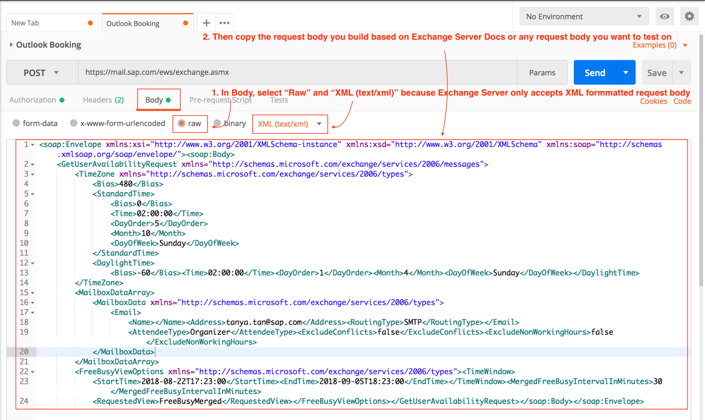

1. After first two steps, this part is automatically generated by Postman

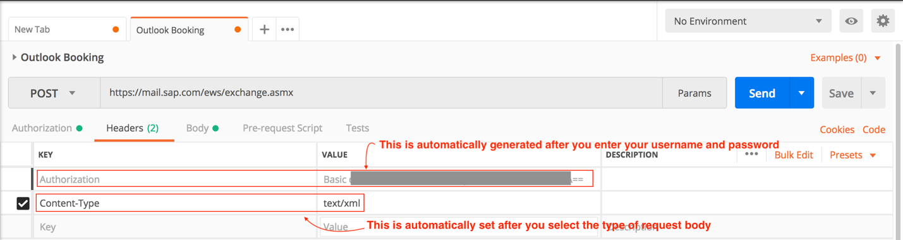

Example of Request Body to get Availability:

|  |
| --- |
| <soap:Envelope xmlns:xsi="http://www.w3.org/2001/XMLSchema-instance" xmlns:xsd="http://www.w3.org/2001/XMLSchema" xmlns:soap="http://schemas.xmlsoap.org/soap/envelope/">  <soap:Body>  <GetUserAvailabilityRequest xmlns="http://schemas.microsoft.com/exchange/services/2006/messages">  <TimeZone xmlns="http://schemas.microsoft.com/exchange/services/2006/types">  <Bias>480</Bias>  <StandardTime>  <Bias>0</Bias>  <Time>02:00:00</Time>  <DayOrder>5</DayOrder>  <Month>10</Month>  <DayOfWeek>Sunday</DayOfWeek>  </StandardTime>  <DaylightTime>  <Bias>-60</Bias>  <Time>02:00:00</Time>  <DayOrder>1</DayOrder>  <Month>4</Month>  <DayOfWeek>Sunday</DayOfWeek>  </DaylightTime>  </TimeZone>  <MailboxDataArray>  <MailboxData xmlns="http://schemas.microsoft.com/exchange/services/2006/types">  <Email>  <Name></Name>  <Address>**VR000000007145@sap.com**</Address>  <RoutingType>SMTP</RoutingType>  </Email>  <AttendeeType>Organizer</AttendeeType>  <ExcludeConflicts>false</ExcludeConflicts>  <ExcludeNonWorkingHours>false</ExcludeNonWorkingHours>  </MailboxData>  </MailboxDataArray>  <FreeBusyViewOptions xmlns="http://schemas.microsoft.com/exchange/services/2006/types">  <TimeWindow>  <StartTime>2018-08-27T22:42:00</StartTime>  <EndTime>2018-09-10T22:42:00</EndTime>  </TimeWindow>  <MergedFreeBusyIntervalInMinutes>30</MergedFreeBusyIntervalInMinutes>  <RequestedView>FreeBusyMerged</RequestedView>  </FreeBusyViewOptions>  </GetUserAvailabilityRequest>  </soap:Body>  </soap:Envelope> |
| Example of Request Body to create a calendar item: <soap:Envelope xmlns:xsi="http://www.w3.org/2001/XMLSchema-instance" xmlns:xsd="http://www.w3.org/2001/XMLSchema" xmlns:soap="http://schemas.xmlsoap.org/soap/envelope/" xmlns:t="http://schemas.microsoft.com/exchange/services/2006/types"><soap:Header><t:RequestServerVersion Version="Exchange2010" /><t:TimeZoneContext><t:TimeZoneDefinition Id="Pacific Standard Time" /></t:TimeZoneContext></soap:Header><soap:Body><CreateItem xmlns="http://schemas.microsoft.com/exchange/services/2006/messages" xmlns:t="http://schemas.microsoft.com/exchange/services/2006/types" SendMeetingInvitations="SendToAllAndSaveCopy" ><SavedItemFolderId><t:DistinguishedFolderId Id="calendar"/></SavedItemFolderId><Items><t:CalendarItem xmlns="http://schemas.microsoft.com/exchange/services/2006/types"><Subject>test</Subject><Body BodyType="Text">test</Body><ReminderIsSet>true</ReminderIsSet><ReminderMinutesBeforeStart>60</ReminderMinutesBeforeStart><Start>2018-08-27T22:52:00</Start><End>2018-08-27T23:52:00</End><IsAllDayEvent>false</IsAllDayEvent><LegacyFreeBusyStatus>Busy</LegacyFreeBusyStatus><Location>Chinook</Location><RequiredAttendees><Attendee><Mailbox><EmailAddress>VR000000007145@sap.com</EmailAddress></Mailbox></Attendee><Attendee><Mailbox><EmailAddress>tanya.tan@sap.com</EmailAddress></Mailbox></Attendee></RequiredAttendees></t:CalendarItem></Items></CreateItem></soap:Body> </soap:Envelope> |

# Different Types of Authentications:

1. Basic Authentication(temporary solution)

It is an encoded string using 64 base with username and password. There is a built in method does that: btoa(username + ":" + password);

1. Oauth Authentication(our next step!!)

As far as an OAuth client is concerned, it asked for a token, got a token, and eventually used that token to access some API.